  Name: | ___________________________________________________ | Date: ___________
Year 10 Mathematics

Investigation 2, 2015

Topic – CAS Equations

Instruction Booklet and Exercises

Instructions for solving equations | Screen shot
Create a new calculator page | 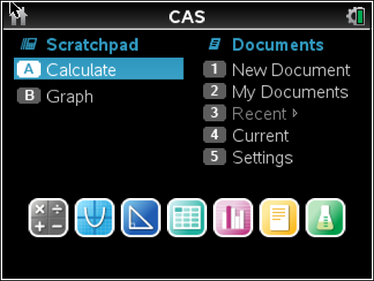
To solve the equation press  Menu→Algebra→Solve  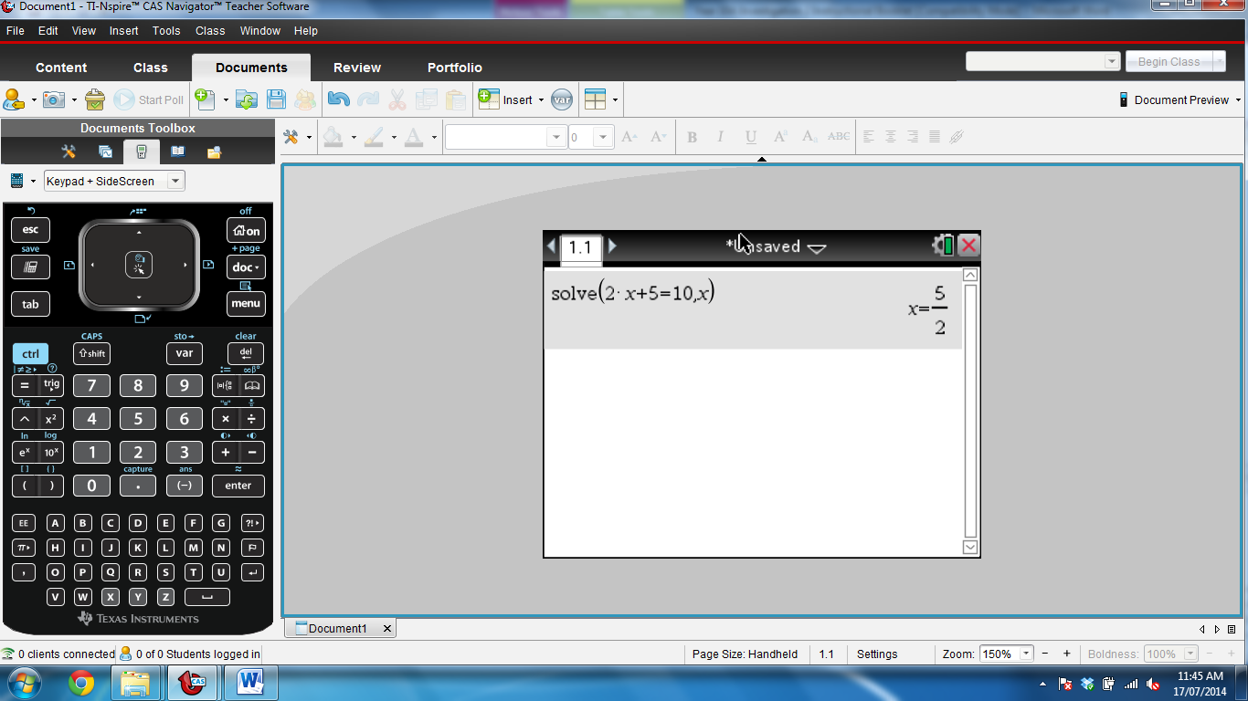 | 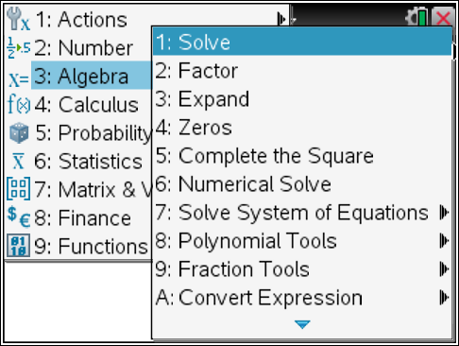
The word solve() should appear on your screen.  Alternatively, you can use the keypad to type the word “solve”, followed by the opening bracket “(“. | 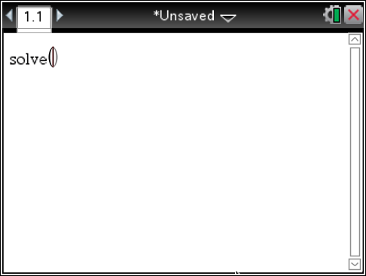
In the brackets, type in the equation. The calculator will automatically place a multiplication sign between the 2 and the x when we press enter later.  Do not press enter after you have entered the equation. | 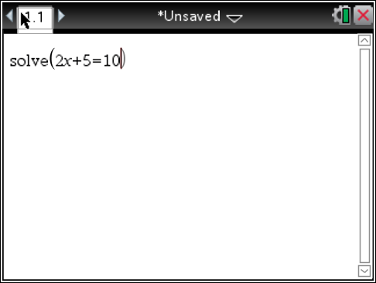
Now we have to tell the calculator what we want to solve for. In this case we want to solve for x, so we need to press  If we don’t type this in, we won’t get an answer.    Now press enter. | 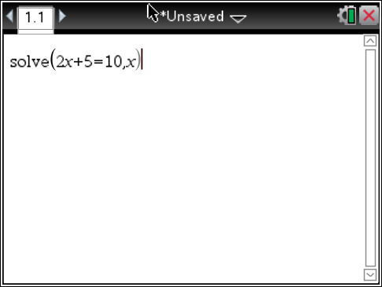  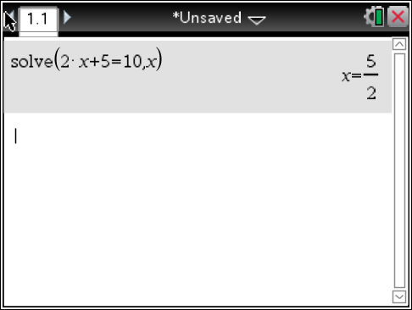
If you want your answer in decimal format, press “Ctrl” then “Enter”   | 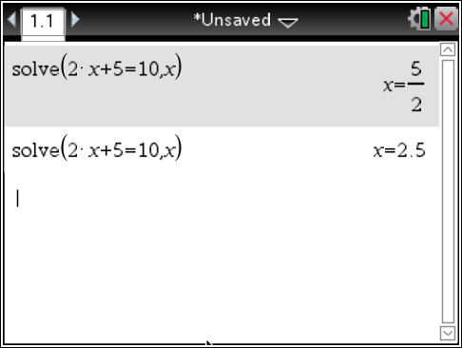

Instructions for Factorising Algebraic terms
Instructions | Screen shot
If you want to factorise the trinomial  $$x^{2}-3x-28$$  here is what to do.  First click on Menu→Algebra→Factor | 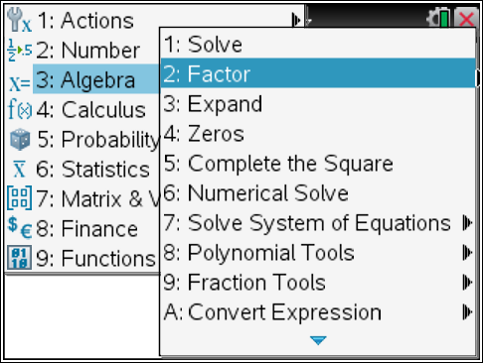
In the Factor brackets you type in the thing to be factorized  i.e. $$x^{2}-3x-28$$ | 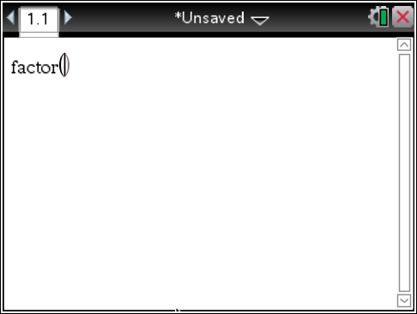
Once to have this press the Enter key | 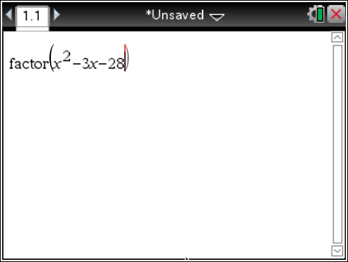
This will bring up the factorised trinomial | 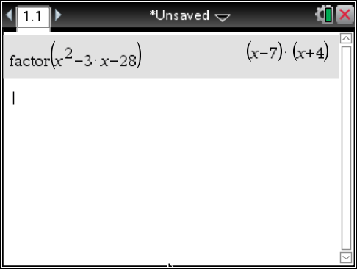

Extensions and Other related things | Screen Shot
Factorise  $$x^{3}+{4x}^{2}-11x-30$$ | 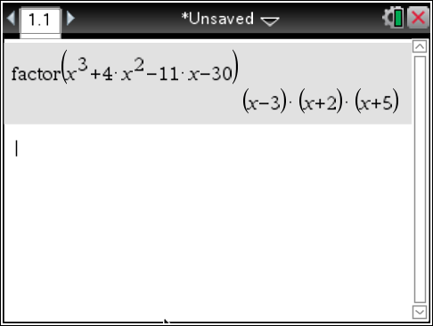
You can also Factor numbers into their prime factors | 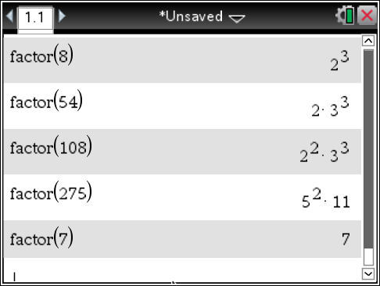
The reverse process to Factor is expand  Note: if expanding 3x(x+2) you need to place a multiplication sign between the x and the bracket. | 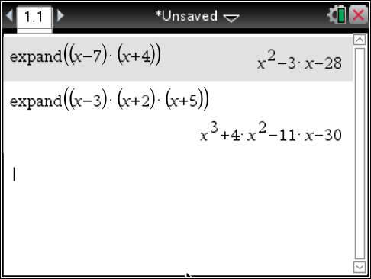

Using the CAS Calculator complete the following questions.
Make sure you write the formula from the calculator into the question for working

Example.
Expand (x-2)(x+3)(x+8)
Solution:
expand((x-2)(x+3)(x+8))
$x^{3}+{9x}^{2}+2x-48$
1. | Expand and where possible, simplify the following, show all working.
a) |  | b)
c) |  | d)
2. | Factorise the following, show all working.
a) |  | b)
c) |  | d)
e) |  | f)
g)

3. Solve the following equations, show all working..
a. 3(5a − 4) − 2(2a + 1) = 2

b.

c.

4. Solve 2(3v − 1) < 8v + 1, show all working.

5. Solve each of the following equations by factorisation, show all working..
a. x2 + 4x – 45 = 0

b. 3(h2 − 5h) = 4(h − 5)

6. Solve the following using the CAS calculator: 3q² +2q− 16 = 0, show all working.

7. Solve the following using the CAS calculator: u2 + 12u − 36 = 0, show all working.

Investigate the following functionality of the TI-nspire CX CAS calculator. Make sure you have good notes so that you can duplicate what you have leant in the validation test.

8. CAS calculators can be used to solve a system of simultaneous equations. Google will bring up lots of results on how to do this. Record below how you would solve the following equations using a CAS calculator.

2.3x + 7.1y = -1
1.3x – 16.4y = 17

9. CAS calculators also help you sketch graphs by helping you to find key points. A cubic graph, for example, has 3 x-intercepts, a y-intercept and two turning points (a maximum turning point and a minimum turning point). Find out how to draw the following cubic on a CAS calculator and how to determine its key features.

$$f\left(x\right)=\frac{x^{3}}{2}-x^{2}-\frac{5x}{2}+3$$

Key features are: Zero’s (the 3 x-intercepts)
Minimum
Maximum
y-intercept

Draw a set of Axis and, with the help of a CAS calculator sketch the graph of f(x).

